 | R.M.K. ENGINEERING COLLEGE  (An Autonomous Institution)  R.S.M. NAGAR, KAVARAIPETTAI, GUMMIDIPOONDI TALUK, THIRUVALLUR DIST. - 601 206.  Phone: 044 67906790;  E-Mail: tnp.office@rmkec.ac.in | 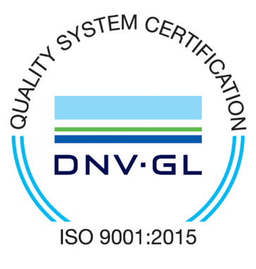

RESUME
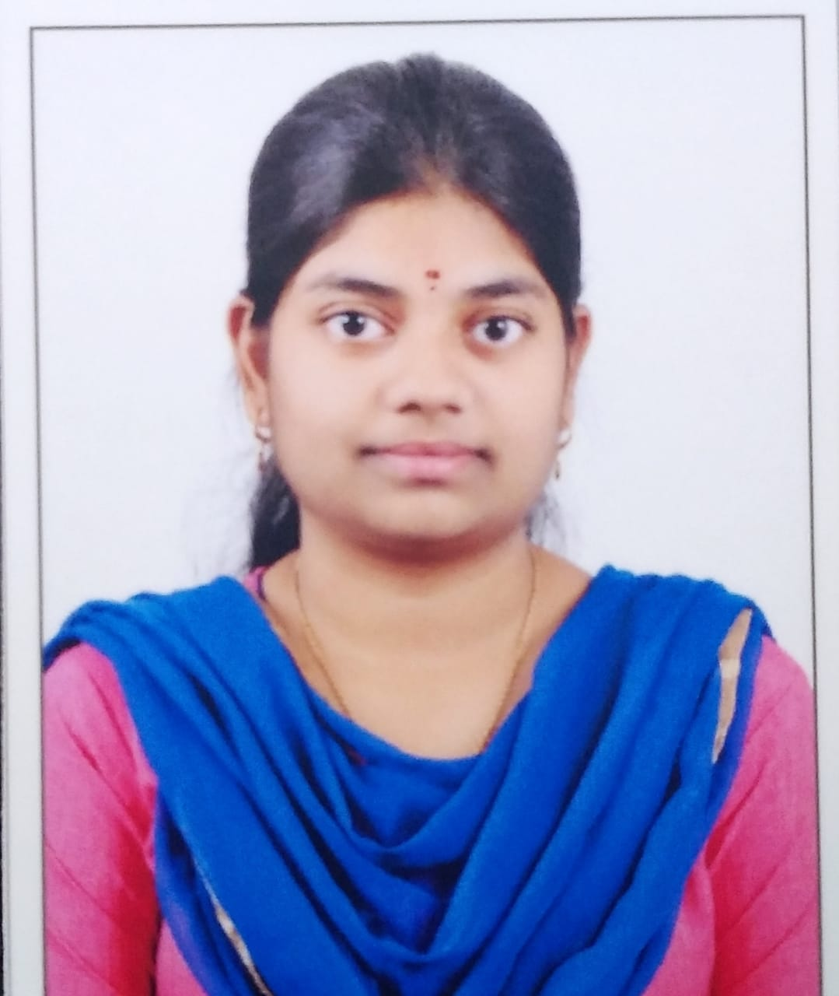

Passport Size Photo
NAME : T.N.Sangeetha
REG.NO : 111719205053
DEGREE : B.Tech
BRANCH : Information Technology
% OF MARKS : 9.05 (CGPA)
E-MAIL : tnsa19221.it@rmkec.ac.in

CAREER OBJECTIVE:

To begin my career in a dynamic environment where I have opportunities to get experience and expertise and to future enhance my career prospertise. A person with entrepreneurship skills and motivational person and good at vocabulary.

ADDRESS FOR COMMUNICATION WITH PHONE NUMBER:

No.26/16, Dev Sai Apartment, Ramachandran Street, Perambur, Chennai – 600011.

Phone No:9840950500
Landline:044 2551 0396

AGE : 20 | DATE OF BIRTH : 26/08/2001 | SEX : Female

NATIONALITY : Indian | COMMUNITY: MBC

COURSE | MONTH & YEAR OF PASSING | SPECIALIZATION/ SUBJECT | % OF MARKS
S.S.L.C | March 2017 | Nil | 96
DIPLOMA | Nil | Nil | Nil
H.S.C | March 2019 | Bio-Maths | 82
U.G.  (FOR P.G. STUDENTS) | Nil | Nil | Nil
Gaps in studies  if any  (mention the no. of years) | Nil | Nil | Nil

CURRENT ACADEMIC PROFILE:

SEMESTER NO. | GPA | MONTH & YEAR OF PASSING
1 | 8.240 | December 2019
2 | 9.520 | April 2020
3 | 8.71 | January 2021
4 | 9.38 | July 2021
5 | 9.40 | April 2022
6
7

Overall CGPA upto recent semester: 9.05

Arrear Status: No History of arrears :
No. of Backlogs (history of arrears if NSA) : 0
No. of Current arrears (if any) : 0

SOFTWARE SKILLS:
MS Office
Python Programming Language
C Programming Language
Java Programming Language
HTML, CSS
MYSQL
Machine learning
Data Science

EXTRA – CURRICULAR ACTIVITIES:

HOBBIES / LIBRARY ACTIVITIES | SPORTS AND GAMES | OTHER ACTIVITIES
Coding, Music | Throwball | -

DISTINCTIONS :

POST HELD | PRIZES WON | OTHER DISTINCTIONS
 | Mental Arithmetic Competition – Runner Up 1

MEMBERSHIP IN PROFESSIONAL BODIES:

Lifetime Membership in IEI, NDL

DETAILS OF THE MINI PROJECTS:

Medical and Blood Donor Website
A Simple Website
Submitted abstract of the Project on the topic of Digital Jewellery.

VALUE ADDED COURSE CERTIFICATION:

DataCamp – AI Fundamentals
DataCamp – Introduction to SQL
DataCamp – Intermediate Python
DataCamp – Introduction to R
DataCamp – Machine learning for everyone
Coursera – Data Science for Math Skills
EDX - IBM – Python Basics for Data Science
HackerRank - Python(Basic)
HackerRank - Java(Basic)
Sololearn – HTML Fundamental Course
Sololearn – Python 3 Tutorial Course
Sololearn – Machine Learning Course
Sololearn – Java Course
Sololearn – Data Science Course

AMCAT SCORE:

Automata fix- 1 Percentile
Core Java (Entry Level)- 11 Percentile
WriteX- 1 Percentile
Computer Science (Level 2)- 11 Percentile
Automata- 10 Percentile
English Comprehension- 83 Percentile
Logical Ability- 98 Percentile
Quantitative Ability (Advanced)- 80 Percentile

ACTIVE PARTICIPATION IN CORPORATE PORTAL:

S. No | Name of the Competition | Idea Submitted
1. | Manthan Hackathon 2021 | Abstraction-based Text Summarization

ADDITIONAL INFORMATION ( If Any ) :
Cyber Security Clifford Chance – Internship
QuantMasters (Artificial Intelligence and Machine Learning) – Internship
Diploma in Computer Application

DECLARATION:

I do hereby declare that the particulars of information and facts stated herein above are true, correct and complete to the best of my knowledge and belief.

Place : CHENNAI Signature :
Date : 30.11.2021 Name : T.N.SANGEETHA
(BLOCK LETTERS)

